

20- Sep- 2017

Dear Sir,

I was very excited to see your vacancy for an [**Assistant, Warehouse**](https://www.bdhonda.com/career/job-details/2)which was advertised on the [**www.bdhonda.com/career**](http://www.bdhonda.com/career)website**.** I am a well qualified and excellent choice for this position.

I have an ability to grow with a job, handle responsibility and build positive relationships with work colleagues at all levels. I am confident that I can bring the high performance to your company.

Beyond that which is already mentioned in my attached resume. I have completed my **Bachelor degree (BBA)** from Presidency University **major in Finance** and **minor in Marketing** and achieve **CGPA 3.72** out of **4.00**. I am someone who knows how to set goals and achieve them.

I very much hope that you will look favorably upon my application by recognizing my enthusiasm, talents and my future potential. My expected salary is 20000/- taka.

Thank you in advance for your time and consideration.

Yours sincerely

**MD. SHADMAN RAHMAN**

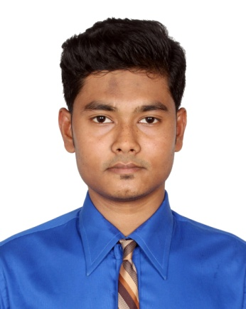 CURRICULUM VITAE

**MD. SHADMAN RAHMAN**

**Mobile No: 01680253099**

**E-mail: shadman8025@gmail.com**

|  |
| --- |
| Objective |

“Seeking a suitable and rewarding carrier, with an esteemed organization, this would offer good advancement potential, challenges and opportunities to zoom my carrier growth, contributing to the success of the organization.”

|  |
| --- |
| Educational qualification |

* Name of the course : **B.B.A(Bachelor of Business Administration)**

Major : **Finance,** Minor in **Marketing**.

Year of passing : **August, 2016**

University : **Presidency University**

CGPA : **3.72 out of 4**

* Name of the course : **H.S.C**

Major : **Commerce**

Year of passing : **2011**

College : **Gulshan Commerce College**

GPA : **4.80 out of 5**

* Name of the course : **S.S.C**

Major : **Commerce**

Year of passing : **2009**

School : **Dakkhin Banasree Model High School**

GPA : **4.44 out of 5**

|  |
| --- |
| Computer Skills |

* Ms office
* Software installation
* Internet browsing
* Email
* Web search

|  |
| --- |
| Strengths |

* Strong decision making power
* Willing to Work in multicultural environment and in group
* Analyze the tasks before work on it
* Have not any ego to cooperate with others
* Motivated others
* Ability to work under presser
* Riding Bike

|  |
| --- |
| Personal details |

Date of birth : 15/08/1994

Father’s Name : Md. Moklesor Rahman

Mother’s Name : Mahmuda Sultana

Present address : 42/1 Meradia Noyapara, Khilgaon, Dhaka-1219

Permanent address : 42/1 Meradia Noyapara, Khilgaon, Dhaka-1219

Nationality : Bangladeshi

NID : 1994269360300034

Passport No. : BN0432339

Height : 5’.8”

Religion : Islam

Marital status : Single

Sex : Male

|  |
| --- |
| Experience |

I was worked in Al-Arafa Islami Bank Limited at Nandipara, Bashabo, Sobujbag, Dhaka branch. My responsibilities were to maintain front line consumer and to open different types of bank account like current, savings, fixed deposit, monthly deposit etc. and marketing and selling ATM Card. I also provided ATM card services and other banking related important information to the consumers.

|  |
| --- |
| Interest |

* Reading Bengali novel, poem and short story book
* Traveling
* Listening music
* Playing cricket, football, handball and cards
* Pet Bird

|  |
| --- |
| References |

**Dr. Nurur Rahman** **Md. Sarowar Khaled**

**Professor & Dean Assistant Professor and Director**

**M. H. School of Business MBA and EMBA Program**

**Presidency University M. H. School of Business**

**Contact No: 01819244835 Presidency University**

**E-mail: rahmann@mail.presidency.edu.bd Contact No: 01965947381**

**E-mail: sarowark@mail.presidency.edu.bd**

Sincerely yours



**Md. Shadman Rahman**